**釋例5-具重大影響力證券投資 (採權益法之投資)**

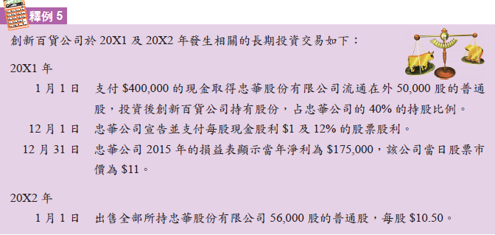

|  |  |
| --- | --- |
| X1/1/1 |  |
| X1/12/1 | ($400,000-$50,000)/50,000=$7; $350,000/56,000=$6.25 |
| X1/12/31 | 畫面剪輯 |
|  |  |
| X2/1/1 |  |